Meeting Minutes 23:00 on 09-03-2026
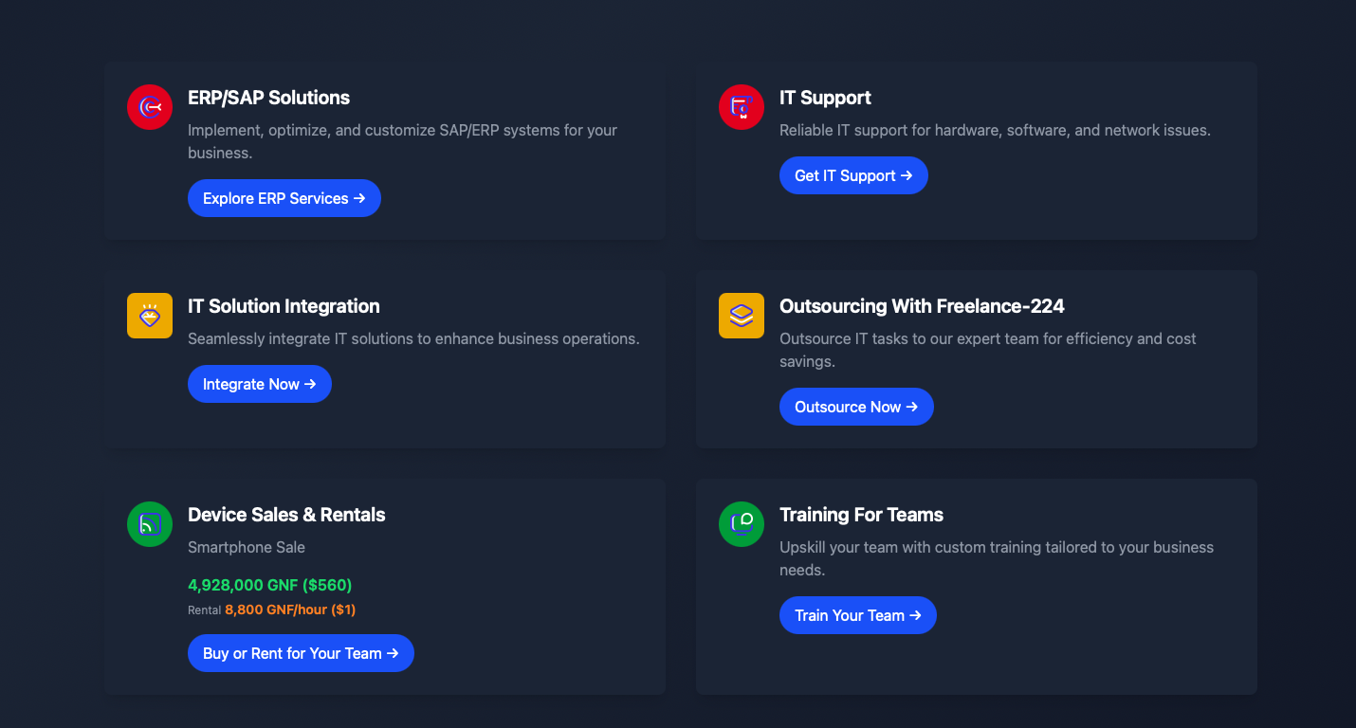

1. CTA Button Navigation
- All CTA buttons on service cards should navigate users to their respective sections:
  - Tech Services: https://freelance2414.vercel.app/tech-services
  - Computer Rental: https://freelance2414.vercel.app/computer-rental
  - Training Modules: https://freelance2414.vercel.app/training-modules

2. Dashboard Navigation Improvements
- Update the sidebar navigation in all user dashboards.
- Include all necessary navigational links relevant to each user role.
- Add a Profile button and dedicated Profile page for every user.
- Ensure the Profile link appears in the sidebar navigation of each user panel.

3. Freelancer Detail Page Improvements
Page:
https://freelance2414.vercel.app/hire-freelancers/info
Required updates:
- Add a “Hire Now” button on the freelancer info page to initiate the hiring process.
- Above the Rating section, display freelancer summary badges including:
  - Years of experience
  - Freelancer level
  - Number of portfolio projects
  - Other key highlights for quick decision making.
Additional issue:
- On the freelancer listing page
https://freelance2414.vercel.app/hire-freelancers
when the language is switched to French, the card content breaks responsiveness and exceeds container width/height. This needs to be fixed.

4. Job Submission Page Enhancements
Page:
https://freelance2414.vercel.app/hire-freelancers/info/job-post
Required updates:
- Add MUI Autocomplete Select for the Skills field.
- The field should allow users to search and select from a large list of IT-related skills.
Additional improvement:
- On the right panel where the freelancer bio is shown, add badges displaying:
  - Experience
  - Level
  - Portfolio project count
  - Other relevant freelancer details.

5. Navigation Bar Language Issue
- When switching the language from EN to FR, the main navigation menu breaks into two lines.
- The navigation items must remain on a single line regardless of language selection.

6. Rental Booking Form Updates
During product booking:

Organization Type Logic
If Organization Type = Corporation, show an additional field:
- RCCM Number

Phone Number Validation
Add formatting and validation rules:
Country Code | Digits | Format
+224 | 9 digits | +224 XX XX XX
+221 | 9 digits | +221 XX XX XX
+225 | 10 digits | +225 XX XX XXX
+233 | 9 digits | +233 XX XX XX

7. Rental Product Booking Improvements

7.1 Auto Prefill Device Type
- Device Type should auto-populate based on the selected product from the rental page.
- Add deviceType field in the product database schema.

7.2 Rental Duration Options
Provide three options:
- Weekly
- Monthly
- Yearly

7.3 Date Picker
- Ensure the Date Picker is fully functional.

7.4 Brand Auto-Prefill
- The Brand field should also auto-fill based on the selected product.

7.5 Add-On Services Logic
If Mobile Device is selected:
Add-on Services
- SIM Data Plan
- Mobile Back Cover
- Screen Protector
Included Accessories
- Charger (for all devices)
- Carrying Bag (for laptops only)

7.6 Rental Page Filters
Page:
https://freelance2414.vercel.app/computer-rental
Add filtering options:
- Search by product name
- Brand filter
- Price filter
- Category filter
- Sub-category filter

8. Payment Method Update
- Remove PayPal from checkout.
- Replace it with YMO payment gateway.

9. Corporate Sales Form Update
- During Corporate Sales booking, remove the section:
“Device Rental Details”

10. Blog Page Issues
Page:
https://freelance2414.vercel.app/blog
Issues to fix:
- The blog listing page is not responsive, especially when translated to French.
- Clicking a blog card does not open the blog content.

11. Refer & Earn Rewards System
Enhance the referral system:
Users should receive:
- Reward points for successful referrals.
- Points can be used for discounts on purchases.
Gamification features:
- Users can also earn badges.
- These badges will appear on the user profile card to show credibility and engagement.

12. Add to Cart Issue
- The Add to Cart functionality is currently not working and needs debugging.

13. Security Improvement
- Protect the following forms using Cloudflare protection to prevent DDoS attacks:
  - Hire Freelancer form
  - Other critical form submissions.

14. Certificate Generation System
Implement a certificate generation module with:
- Unique certificate identification number
- Unique certificate stamp
- End-to-end encryption/decryption for certificate verification
- Use a secure encoding or cryptographic algorithm for the certificate stamp.

15. Signup Form Role Restriction
- Remove the Admin role from the public signup form.
- Admin accounts should not be created via public registration.

16. Signup Form Field Updates
Modify the signup form fields:
New fields to add:
- Nickname (after Name)
- Phone Number (after Email)
Updated order:
Name → Nickname → Email → Phone Number → Role

17. OTP Verification
Implement OTP verification during signup.
Users should be able to choose verification via:
- Email
- Phone number

